**GROUP 4 DOCUMENTATION**

Immersieve beleving “De Kinderspelen”

*Group members*:

Niels De Backer, Jentse Vander Hulst, Malika Kitapbayeva, Silvia Severins, Feiran Zhang.

*Composition*:

Niels and Jentse are from the IT department, so they are mainly responsible for the technical and VR-making part, and Silvia, Malika and Feiran provide more ideas about the concept, testing and helping them with the visual part.

*Function*:

This is a project for the Toy Museum in Mechelen, so the main goal is to let children familiarize themselves with different games which have disappeared from our daily lives, and also encourage children to play more games outside with their peers.

*Storyflow of the VR Simulation*:

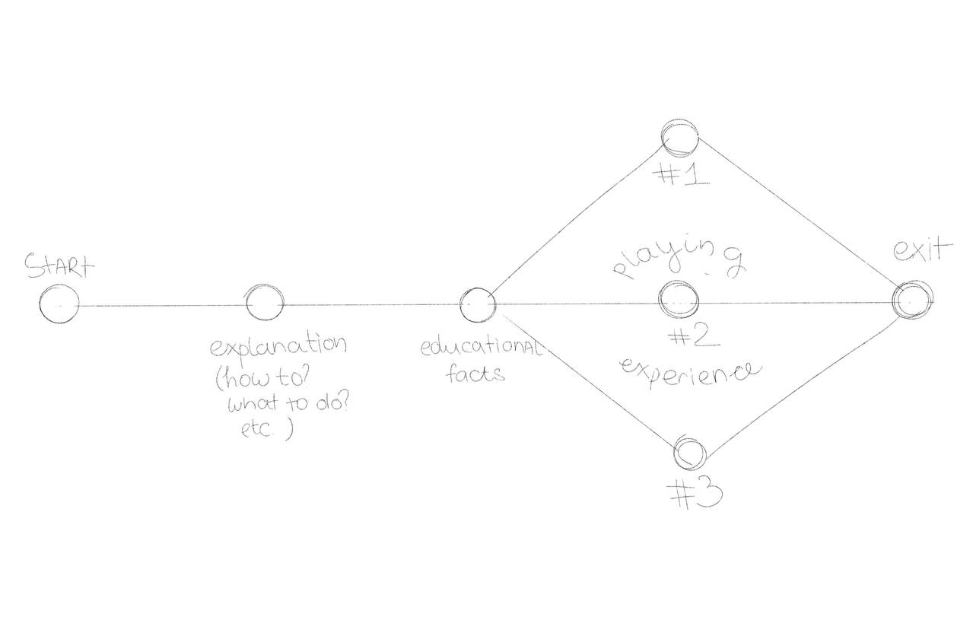

The linear structure is designed to make this interactive game engaging, educational, and also fast-paced, as museum visitors typically come in groups of children.

And a couple of first drafts of our ideas for story structure:

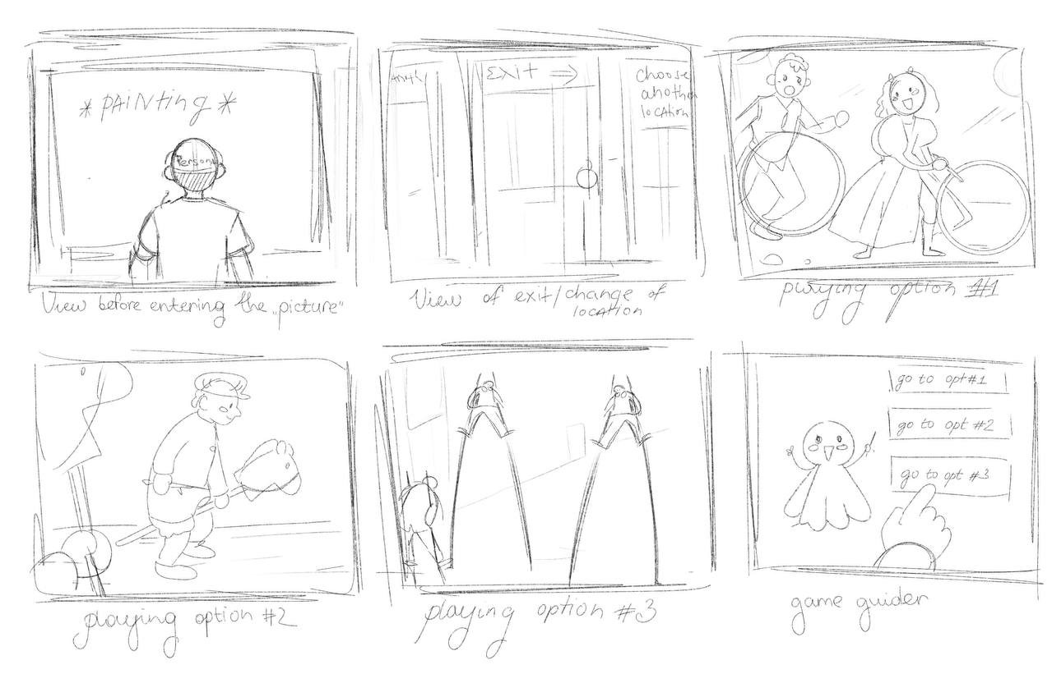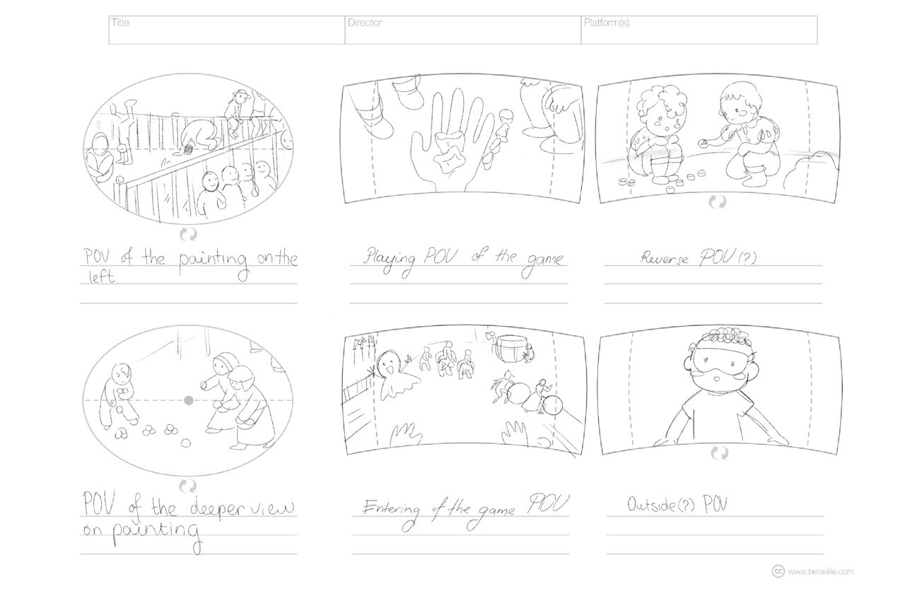

*Why VR is an added value compared to the situation without a VR component?*

We were asked to create a VR project for the new location of the museum, in which they have a small room dedicated to the painting 'Children’s Games' by Bruegel. The nature of the project started when the museum wanted to relocate closer to the center of Mechelen. Their new place sadly didn’t have the same space the current one has and they had to let go of their recreation of the painting in real life. Thus this project was born, VR requires way less room so why not make it in VR to offer an even better experience!

Museums are known to be innovative with their approach to teach people about history or technology, think about Technopolis. The same can be done here, we’re innovating the experience users can have with history by not just providing them a look at the old games kids used to play with but also a unique first hands on experience at playing with them.

VR shines at captivating users in an immersive experience, it brings things to life with the use of animations, interactables and ambient sound. Besides, after all we are talking about a toy museum that’s meant to showcase games and hopefully instigate kids to play more. Mainly with physical things but due to the nature of the objects shown and their rarity plus fragility it’s hard to let each kid have a try with them without breaking the toys. Thus this is also where VR can come in handy, toys can’t break in VR and we are able to provide the kids to play with the toys so they can get a better understanding of what they were like. This hopefully stands out with the kids more instead of just reading about it behind a glass case where they are displayed.

Also when you think about it VR will in the future also be displayed as a toy from the 21th century so not only is it a practical instrument to have the kids have an enjoyable experience but it can also be a form of art for the museum. We feel like VR might attract more people to the museum as well, after all who doesn’t want to try VR for the first time in their life, this can be for kids but also adults. There are probably not that many museums that might offer an experience like this around so this would definitely make them stand out more.

*Testing Process:*

Our target audience are kids around the age of 10-13 but not limited to this target group. It plays like a game with several minigames in it, so people familiar with video games should be able to recognize the patterns. For testing purposes, I asked a few friends who live nearby to test the application and asked for their feedback on how it felt and played.

For example: during one of the testing processes we found that the user was flying on certain VR devices.

Another example is the walking speed which felt way too slow, so we increased it to make for a more immersive experience.

The few kids that live close in my town tried the VR game in my room where I have a valve index set up, most of them seemed eager to try their first VR experience and liked playing around with the objects in the game. The goal initially was not as clear as we I had hoped but due to the other kids watching the main monitor and following along they we’re able to figure it out. This is also the recommended approach we proposed to the museum to set up a monitor so the other kids waiting to play can follow along. This should make the experience feel way more intuitive and also share some resemblance amongst the other kids.

*Teams experience in a multidisciplinary collaboration:*

We started off with a brainstorming session about words related to Toy Museum, everyone had good proposals and we had the same sort of ideas. So the direction we wanted to go was clear from the start.

Afterwards, we took the initiative to set up a meeting with the museum to present our proposal and ask for their feedback/ideas of what to do with the project. They gave us a brief run through of what they expected and why this VR project is necessary.

We then started working together to build the storyboard and flow of the story that users would experience in the game. There were a few ideas proposed in our group and we had some trouble deciding which one we ultimately wanted to go for. Once we decided on the storyboard we went ahead and started setting up the scene and general moodboard that we wanted to incorporate in the scene. This was done with the input of our art student who advised on what colors and texture to use to make it represent the painting.

*Conclusion of each individual in the multidisciplinary collaboration*:

*Jentse:* Personally I enjoyed working together with the people on my team, we went to the museum together to meet the people we were designing the project for. Shared ideas alongside them and I felt like my input had meaning. I had fun brainstorming ideas to implement in the game and how to accomplish them from a technical point of view, I like tinkering around in Unity trying to find new and innovative things to accomplish certain goals. Being able to implement someone else’s idea that they suggested and seeing them watch it come to life in the game makes me feel accomplished and satisfied with the work being done. There were a lot of ideas but sadly not every single one could be implemented. Overall I am happy with the work I was able to provide and am proud of the result we delivered at the end. It was a new feeling working together with student from other courses and to see their perspective, especially exchange students. Communicating in English was a challenge at first but it became a learning experience and helped me speak more confident in English. I regularly make small unity projects in my free time as a hobby but they don’t feel as satisfying as working together with other people on the same goal so i’m really glad i could participate in this project with the people from my team, I hope to have more experiences like this in the future.

*Niels:* The mixed reality multidisciplinary collaboration was a very different kind of experience in software development than I have had in other classes. Working with people from other disciplines was a new thing and because of this, there were a lot of things to learn from it. The development of the application itself wasn’t that different from the usual development with Unity and was even a bit easier to manage since there were only 2 people working in Unity, which is less than the past projects. However, this did require us to work harder than on the previous projects as it was still a big project for 2 people. The biggest challenge thus became how we could make use of the non-IT students’ different skill sets in the context of this project. Having 3 extra people work on the project could be a huge help so this was very important for the project. They ended up helping with tasks like documentation, brainstorming and presentation. In my experience this project was a great learning experience on communicating with different kinds of people to reach a common goal.

*Silvia:* I found it an interesting and educational experience. I learned more about how to create a VR experience. During the process, everyone could share their ideas with the group. There was good communication within the group. We also made a groupchat, where we could continue to communicate with each other. The IT students tried to implement as many ideas as possible and involved us in their work. I enjoyed working with students from other departments. It’s also new for me to work on a project with people, who don’t speak Dutch and communicate in English.

*Malika:* For me, it was an exciting experience since I had never studied in that field but was always curious about how everything works in VR and computer game techniques. Thanks to this class, I gained really interesting pieces of knowledge. Also, as an Erasmus student, I have only half a year to explore everything about the country and make new acquaintances. Personally, it was a really nice class for me because I got to work in groups with full-time students and visit a toy museum in Mechelen, all together. Throughout the semester, we had many ideas about how to make our project interesting for kids and how we could implement some games in our university project. I think that with more time and practice, we could have expanded and made that little project even more enthralling.

*Feiran:* The multidisciplinary collaboration has been a completely new experience for me. The immersive storytelling bachelor class inspired my next project and got me thinking about the possibilities of combining theater with technology or immersive experiences. I chose the topic of a toy museum because I am interested about playful elements. We visited the toy museum together and realized that bringing VR into people's perspectives is really important. We brainstormed together, putting ourselves in children's perspective and thinking about how to make stories and interactive game elements more engaging. Meanwhile, I gained more knowledge about the software after communicating with two IT students, such as how to change colours and use specific images to enhance the texture of objects etc.. If I summarize this multidisciplinary collaboration, I would like to say thank you to all my teammates for their help and contributions; I learned a lot from them. However, I think even as an art student, it is crucial to have a certain level of software knowledge, enabling better communication and collaboration.

*What are the next steps to go from your prototype to a VR product*

First of all, we would like to collaborate with some dedicated graphic design students to create better looking and more accurate models for the scene, think about recreating the kids in the painting with matching clothes etc, as well as the houses. Then adding animations to said objects to make the scene feel more alive, furthermore, we would like to discuss what the next course should be with the museum. Maybe certain things need to be changed, redone or added? We also discussed beforehand how they would like to integrate the VR project into the museum, so we want to align the ending of the game differently. Should it have a clear ending with an end screen or be a continuous loop so each child can hop in and start a fresh new experience after the other one is done playing, or should you be able to jump in after someone left off at some point and continue from there? Also since it's an activity that will most likely involve lots of other kids we were thinking about possibly making the experience multiplayer since the museum would like to set up 3 of these boxes to run the VR simulation, so being able to play along with other kids could be a fun experience as well in our opinion.